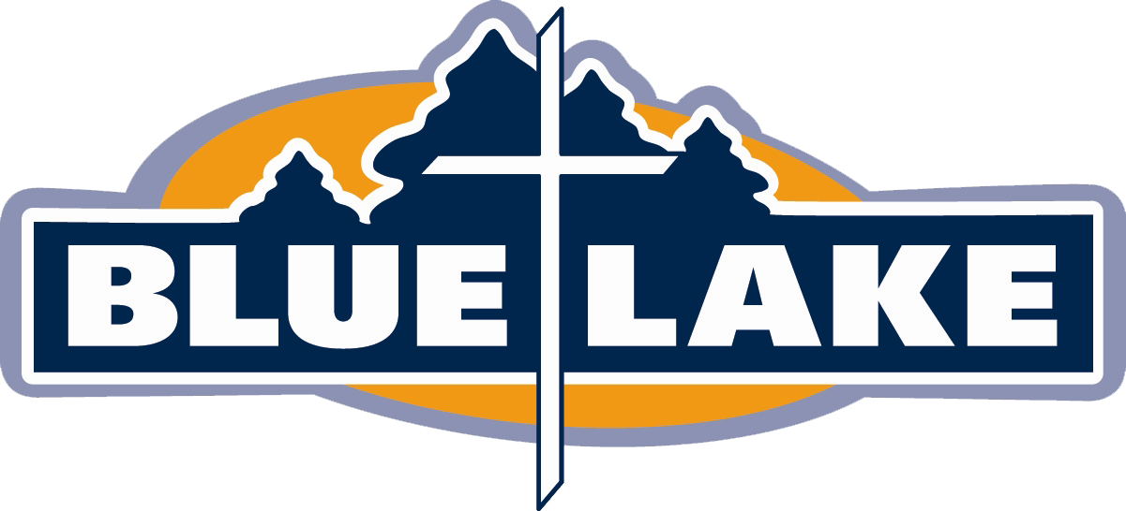

Blue Lake
Sponsored Event Coronavirus Precautions and Procedures

Revised: January 2021
Blue Lake Responsibilities

- A daily temperature check for all employees will be performed
- Employees will wear masks indoors at all times (unless eating)
- We will disinfect every building used before and after a group leaves
- We will place hard limits on group sizes
- Hand sanitizer will be available around camp
- We will place personal distance markings and traffic direction arrows in high traffic areas
- There will be mandatory temperature checks for ALL at arrival (less than 100.00 F)
- We will disinfect high traffic surfaces regularly
- We will place signage throughout camp about Coronavirus prevention practices
- Outside activities will be scheduled and planned around maximizing distance and time between people and groups
- If social distancing cannot be maintained in an outdoor activity, masks will be worn. Exclusions include high impact athletic activities and water activities. (i.e. masks will be required in the GaGa pits and around campfire, but not required during capture the flag)
- Inside activities will be used sparingly when outside activities aren't practical (weather) AND masks and social distancing can be used.
- Musical worship times will require use of masks
- For overnight events: Housing in each cabin will be capped at half capacity. Cabins will only be assigned to one group per cabin. Oakwood rooms will be assigned to one group per hallway/section
- We will suggest strongly to each church group to have their own chaperone for every cabin they occupy
- 1 week after the conclusion of the event, a Covid questionnaire will be sent out to determine if it is possible there was any transmission during the event.

Blue Lake Dining Hall Procedures

- Kitchen staff will follow all health department guidelines and executive orders currently applicable and in affect.
- Dining hall capacity will be at the level currently ordered by executive orders or the health department and will be posted at the entrance
- All staff will wear masks
- Distance markers are placed throughout the dining hall
- Tables used will be at least 6 feet apart from all seats
- Every table is disinfected between meals
- Disposable or single serve items will be utilized whenever possible
- Only Blue Lake staff will handle food and drink service, including drinks and seconds
- Guests in the dining hall will sit at tables with others from their cabin, no intermingling between tables or cabins
- Guests in the dining hall will wear a mask when not seated at their table
- Guests should stay seated until they are finished eating and leave as soon as practical for their group

Volunteer/Chaperone/Dean Responsibilities

- Monitor and enforce social distancing and mask wearing within your group or cabin
- Wear a mask at all times when indoors
- Instruct your participants on hand washing, coughing and sneezing best practices
- Instruct any potential participants who have shown signs of respiratory illness in the past two weeks, or has come in contact with someone who has, to stay home
- Temperature check your participants before you travel together to Blue Lake (100.00 F)
  - If one person that has a high temp when they arrive at camp, all will be sent home
- Inform Blue Lake staff of ANY potential respiratory illness on property immediately

